Experiment-7

1.Display 1 to 5 students details

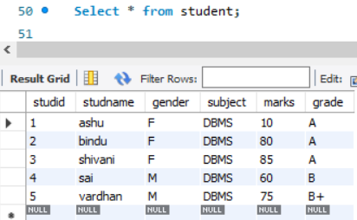

2.Display who got grade A

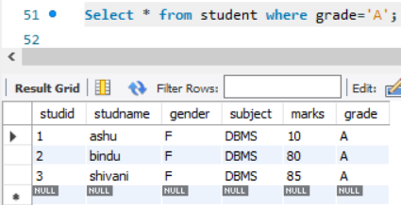

3.Display whose mark is less than 50

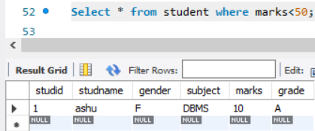

4.Display student id and name

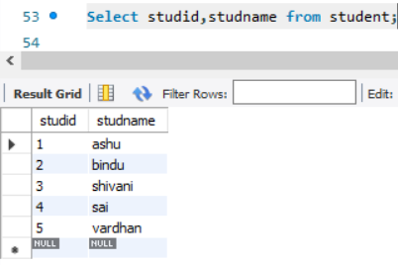

5.Display the student id and name whose mark is 50 to 60 and female

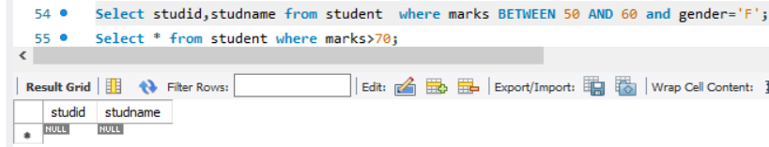

6.Display the list of students who gets greater than 70

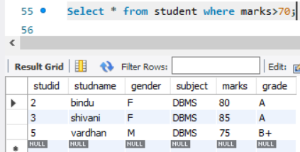

7.delete the failure students

Display complete table

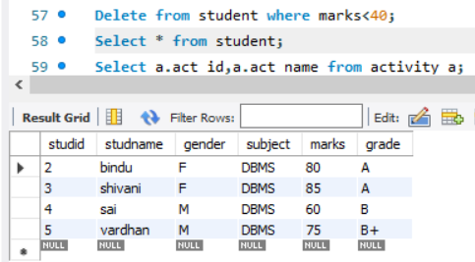

8.display activity id,name using object

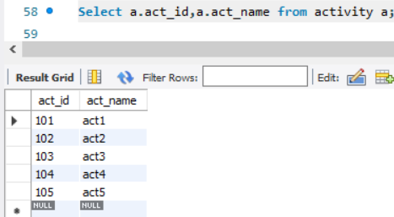

9.Add course to student table then insert values.display student id,faculty id using course name condition with object

